**Chapter 4: The social dimension in the European Higher education area**

**Part of the BFUG implementation report**

**- draft version – do not quote – not for circulation –**

**July 1, 2011**

## 1. Introduction to social dimension in higher education

In the Bologna process, the social dimension entered in the communiqués in 2001 and thus later than most other issues (with the exception of lifelong learning). However, it gained significant attention in the following years. In 2001 the Prague Communiqué focused on the inclusion of students and the need to make mobility opportunities available for all. In 2003 in Berlin ministers focussed more broadly on social cohesion of the student population and social and gender inequalities. In particular they mentioned the need to remove obstacles related to students' social and economic background based on comparable data. These general and specific commitments to make higher education accessible to all were renewed in Bergen in 2005, emphasising the obligation of governments to help students from "socially disadvantaged groups" to widen access.

Despite this repeated reference to the social dimension aspect of building the European Higher Education Area (EHEA), until 2007 there was no precise and commonly accepted definition of the social dimension in higher education. In London 2007, however, the ministers agreed on a comprehensive definition of the concept. The goal of the social dimension of higher education is that, "the student body entering, participating in and completing higher education at all levels should reflect the diversity of our populations". Ministers also emphasised that "students [should be] able to complete their studies without obstacles related to their social and economic background" (London Communiqué 2007, p. 5).

The report of the BFUG Working Group on the Social Dimension and Data on Mobility in 2007 further clarified that the social dimension is understood as the process towards achieving this overarching goal (BFUG 2007, p.11) – and thus as a large sphere of activities where governments can enact policies.

The integrated implementation report uses this understanding of the social dimension as a concrete goal as its conceptual basis and provides an analysis of the measures undertaken to achieve that goal, thus capturing the second element of the social dimension as defined by the BFUG working group.

In 2007 the ministers also agreed to report on the progress made on this trajectory and in 2009 decided to set measurable targets "for widening overall participation and increasing participation of underrepresented groups" with a goal to achieve them by 2020 (Leuven/Louvain-La-Neuve communiqué, 2009). Eurostudent and Eurostat (2009) also highlighted the need to have more comparative research on the social dimension of higher education based on recent data to be used by policy makers.

Based on this call for more precise and comparable data, Eurydice examined the social dimension in the European Higher Education Area (EACEA/Eurydice 2010, 2011) and concluded that significant changes in higher education systems have taken place, but that challenges remain. In particular setting public benchmarks or targets was not greatly developed in the EU and the Bologna countries and monitoring systems are not yet developed to any significant degree. In addition, where monitoring took place very different aspects of the composition of the student body were in focus.

Very few countries have linked their policy on the social dimension to the Bologna commitment of raising the participation of under-represented groups to the point where the higher education population mirrors the overall societal distribution. While special measures to assist specific groups based on e.g. socio-economic status, gender, disability and ethnicity exist in many countries, these are rarely a central element of higher education policy. In addition, the social dimension of higher education is understood differently from one country to another.

This chapter builds on these previous reports and brings together available statistical information on student background and educational attainment with administrative data on the social dimension and funding of higher education in Bologna signatory countries.

**Organisation of the chapter**

The chapter starts with an overview of how higher education systems have developed in the last decade. The section also discusses the effects of background characteristics of students on higher education participation and attainment. These indicators set the context for further analyses of social dimension policies in higher education. They also provide information relevant to an assessment of the goals set by the ministers.

This mostly statistical section is followed by an analysis of different national approaches to widening participation in higher education. In particular, the focus lies on whether under-represented groups are expressly defined or whether there are other policy approaches. This section provides an understanding of the regulatory context within which widening participation is addressed and measureable targets have been set and are being monitored as the ministers agreed.

Following on this, actual measures to achieve these targets will move into focus....

The chapter concludes with a look at the financial side of higher education by contrasting major costs charged to students (e.g. tuition fees) and data on student income via direct and indirect public student support, family support and self-financing through paid jobs.

## 4.2. Statistical information on the impact of students' background on their participation in and attainment of higher education

This section provides an overall picture of aspects of the social dimension by looking at higher education participation and attainment of certain groups of the student population. These indicators will set the context for further analyses of social dimension in Higher Education and provide information relevant to an assessment of the goals set by the ministers.

**PARTICIPATION**

This first section of statistical indicators addresses participation. In other words, it shows snapshots of the student population at a given point in time. This look at students analyses the population to whom the policies adopted by the countries apply and who can be directly affected by these policies.

The first element concerns the overall development of the higher education sector as a whole within which the social dimension (and actually most higher education policy) takes place. In a time where labour markets and the general move towards a knowledge-based economy increasingly require higher education degrees, understanding the challenges arising from participation in higher education becomes more and more important. This expansion of higher education has been reaffirmed by all signatory states repeatedly in the communiqués and other international declarations.

Figure 1: Trends in the number of students in national tertiary education systems (ISCED 5/6) compared to 2000, 2004-2008

Year 1999 = index 100

Source: Eurostat

Since the inception of the Bologna process (and the subsequent establishment of the EHEA), the European higher education sector has noticeably expanded. Figure 1 presents data on student numbers for the period 1999-2009. It presents stocks of students per year, compared to 1999. It shows that, compared to 2000, EU-27 student numbers have increased by 25 percent. However, developments between countries vary greatly. The Czech Republic (80%) Cyprus (187%), Greece (51%), Lithuania (96%), Malta (79%), Poland (54%), Romania (169%) Slovakia (91%), Latvia (53%), Iceland (99%) and Turkey (149%) have experienced rapid expansion in student numbers. In comparison, the growth in student numbers in Bulgaria, Portugal, France, Italy and Finland is relatively low at under 13 per cent. Spain's development was almost static. It is worth noting, however, that compared to 1999 no country has seen a decrease in students numbers.

This is not to say that development has been uniform. While most countries register a progressive increase in student numbers throughout the whole period 1999-2009, others have experienced an uneven development. The evolution of student numbers in Bulgaria, Germany, Luxembourg, Italy and Austria, for instance, has been characterised by a decline in student numbers over several years, followed by positive gains,even though Italy has experienced a renewed decrease in recent years. Spain even recorded a decrease in the index in all the years until 2009 before increasing its student numbers for the first time in 2009. The opposite trend of initial strong increase and subsequent lower gains can be observed in Latvia, Denmark and Hungary.

Figure 2: Trends in participation rates in tertiary education in the 18-34 age group, 1999-2009



Source: Eurostat

The increase in student numbers also shows up in the participation rates of the countries. In general participation has increased by a third across all countries, reflecting the continuing move towards the massification of higher education. In the EU-27 in 2009 15% of the 18-34 old population were enrolled at a higher education institution. Simply averaging across all EHEA countries (for which data is available) the participation rate increased from 1999 to 2009 from 11% to over 14 %. Growth in participation rates, however, is uneven across countries. In those countries with the highest absolute growth in student numbers the participation rates have also increased in the 18-34 age group by more than 50 % (CZ, CY, LT, RO, SK, IS, FYROM, TR, EL). A number of other countries experienced a more uneven development (AT, MT, NO, EE, FI, IS), hitting a peak in the mid-2000s and slightly decreasing student numbers since then. Only Spain exhibits a continuous decrease in participation rates throughout the decade.

**Gender balance in higher education**

Ministers agreed that those participating in higher education should reflect the composition of the overall population as closely as possible. One important indicator in this regard looks at the sex of students. Here, the historical trend is a reversal of the tendency for men to outnumber women in higher education.

Figure 3 shows that in the beginning of the first decade of the Bologna Process more women than men entered in higher education. This is reflected by the fact that, with the exception of Switzerland, all countries in the EHEA for which data is available were positioned to the right of the 50% vertical line. This development has continued throughout the decade in half of the countries. For those countries above the 0% horizontal line, the percentage of women in higher education has increased between 2000-2001 and 2008-09.

The figure shows that overall the gender imbalance has increased slightly. However, more than half of the countries improved the parity between men and women in access to higher education over all fields. But divergent developments stand out. Of the 37 countries (for which there is data) in 12 a higher percentage of women entered higher education in the beginning of the decade, but by 2009 the relationship had moved more towards gender balance. One country, Cyprus, has seen the picture completely turned upside down, and now has more men entering higher education than women. In Switzerland fewer women than men entered higher education in the beginning of the decade (44.4% in 2002), but by 2009 parity was almost achieved (49.6% female entrants). In contrast, in SK the student population was balanced in the beginning of the decade (49.9% female entrants), but by the end of the decade the country had the 4th highest percentage of women entering higher education (58.4%).

Figure 3: Percentage of women in new entrants in tertiary education, 1999-2009

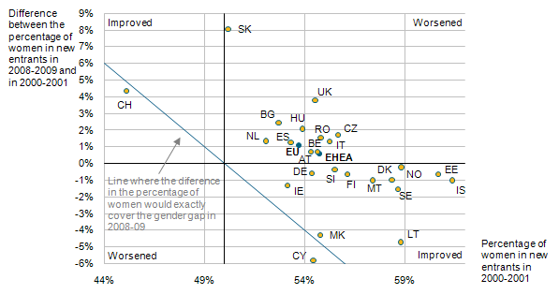

**Notes:** The value for 2000-2001 corresponds to the average level of the academic years 1999/2000 and 2000/2001, and the one for 2008-2009 the average of academic years 2007/2008 and 2008/2009.

The value for the EHEA is the median of all the countries for which data is available.

**Source**: Eurostat

The overall overrepresentation of women in higher education, however, needs to be qualified. When looking at gender balances by study field, another picture emerges (figure 4). Women dominate in the education field, in veterinary sciences and in health and welfare. Men, on the other hand, are predominant in computing, in engineering and engineering trades and in transport services. And while in mathematics and science, as well as in manufacturing and processing and environmental protection, the median is around 50%, the spread across countries is very wide.

Figure 4: Percentage of women in new entrants in tertiary education by field, academic year 2008/2009 (distribution with min/max across countries; median and 10/90 percentile)

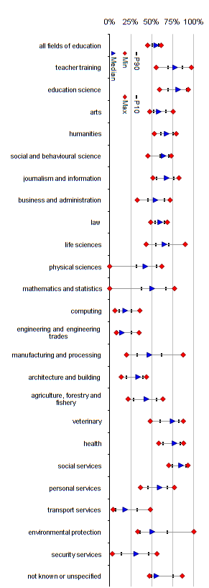

Source: Eurostat

Overall, this indicator highlights that when looking at the importance of gender in higher education participation, taking a broad look across study fields does not yield sufficient information. While overall participation by women is higher, this picture needs to be adjusted when looking at particular policy fields. This also means that policies should not try to address the issue with a broad stroke, but should rather be more fine-grained.

**Migrant participation in higher education**

The integration of Europe and globalisation in general have led to increasing cross-border migration. In many countries, a significant share of the resident population does not have the citizenship of the country. This brings a further dimension of higher education to attention: participation by citizenship. In a European Higher Education Area that provides accessible higher education for all (2005 Communiqué), migrants should constitute a share among the student population that is equal to their share in the population. But not only that, they should also participate to a more or less equal degree in higher education.

Figure 5 depicts participation rates of migrants compared to non-migrants[1]. In difference to the problems that an indicator based on citizenship has when talking about mobility, in this case the question of whether an individual has been living in a country for a long time or whether s/he has come to a country only recently (e.g. for the purpose of study) is irrelevant. In fact different participation rates for migrants show that the ministers' goal to open higher education participation to all societal groups is still a way off.

For 22 countries data differentiating between migrants and non-migrants in higher education is available. It shows that in 18 countries participation rates for migrants are lower than for non-migrants. In 12 of them this gap is larger than five percentage points with Estonia (13%), Greece (18.5%), Spain (16.3%), Italy (19%) and Switzerland (10.5%) having the largest gaps. A second group of 4 countries (CZ, DK, CY, HU) has the same (or very similar) participation rates for the two groups. In these countries migrants are as likely to participate in higher education as non-migrants, thus reaching the goal ministers set themselves. The United Kingdom stands out among those countries as migrants show a much higher rate of participation than non-migrants (22.4 % v 14.1%). This exceptional situation may be partially explained through the attractiveness of the UK higher education system for international students, as the figures on student mobility illustrate (see figure [mobility chapter]).

The data further shows that the numbers of migrant students is relatively low in those countries with a large gap between the two groups (this time including the United Kingdom). When we look at overall participation rates we see that they are often very similar to the non-migrant participation rates. The closer the two data points lie together, the less impact the different participation rate for migrants has. This points to overall small numbers of migrants in higher education.

Figure 5: Participation rates in tertiary education among the migrant and non-migrant population 2009

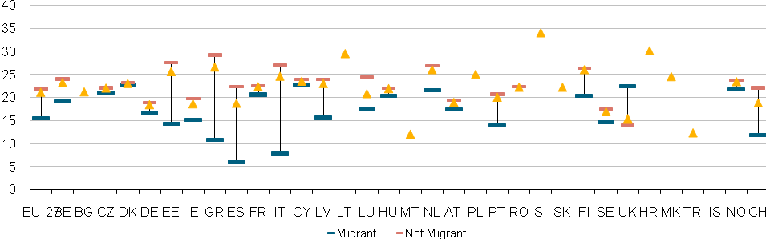

Source: Eurostat LFS

**Early school leavers and higher education**

The reasons for these lower participation rates, however, are not (only) linked to access problems and admission to higher education. The reasons can be found clearly at earlier education levels. Data on early school leaving (figure 6) for those countries showing large gaps in higher education participation rates also show that it is much more likely for students with a migrant background to leave school early. The picture is particularly striking for Greece (35.5 percentage points difference), Spain (17 percentage points difference) and Italy (25.6 percentage points difference). In addition these three countries, together with Turkey, have by far the highest rates of migrant early school leavers with more than 40% of the underlying population. In only four countries (NO, PT, IE, NL) are the early school leaving rates for both groups roughly similar, while in the UK the relationship is inversed with more non-migrant students leaving school early than migrant students.

Figure 6: Early school leavers as percentage of the migrant, non-migrant and total population 2009

Source: Eurostat LFS

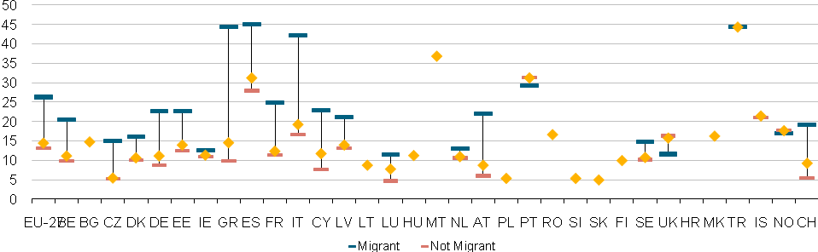

As figure 7 shows, the higher early school leaving is among students with a migrant background in a country, the lower the participation of migrants in higher education. This indicates that measures to foster the participation of people with a different citizenship status must start much earlier in primary/secondary school rather than at the level of higher education. Furthermore, non-citizens have more need for flexible access to higher education.

Figure 7: Relationship between early school leaving and higher education participation among students with a migrant background 2009

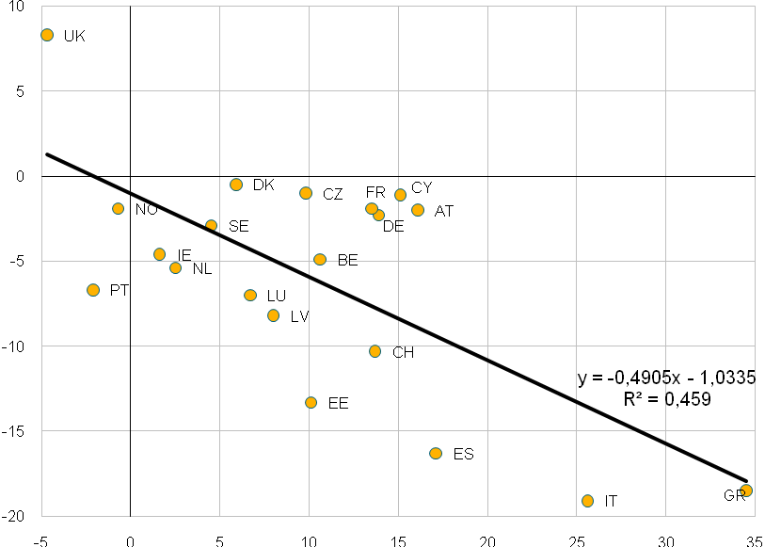

*Source:* Eurostat LFS

**Explanatory note:** Countries above the horizontal 0-line means that more migrants study than the ESL rate would indicate; in countries under the line migrant students do not only leave school earlier than non-migrant student, but even when they do, they are even less likely to go to HE.

Overall, a picture emerges showing that in most countries people with a migrant background and those leaving school early are consistently underrepresented in higher education. To increase their participation in higher education requires a political effort to provide support measures, especially for migrant students, and the establishment of alternative and more flexible access routes, for early school leavers. These two dimensions of social dimension policy are addressed in section 4 of this chapter in more qualitative detail.

**ATTAINMENT**

The previous two figures already bring together two different aspect of the population, namely participation and attainment. While participation looks at the current student population, attainment is a backward looking indicator based on past educational performance. It takes stock of existing educational achievements in a population and focuses on graduates rather than students. These indicators, therefore, are well suited to identify persisting problems within a system. The main problem with most of the attainment data presented in this report is that it is survey data and its reliability depends on sufficient responses.

**Educational background of students and attainment**

One strong indicator for the fairness of a higher education system is the issue of to what extent educational attainment is passed down through generations. If the EHEA countries want to achieve their commitment made in the London communiqué that students should complete their study without obstacle to their social and economic background, looking at the effect of parental educational attainment is crucial. The OECD has shown the financial benefits from higher education (Indicator A7, Education at a Glance, OECD, 2010). Educational attainment also is a strong indicator for the social background of a student. It has been shown that the educational level of parents strongly influences educational attainment (e.g. Koucky, 2010), even though data from the 2005 also shows that this relationship has been diminishing (Eurostat/Eurostudent, 2009, p.67).

Figure 8: Difference in chances to have a higher education degree by parental educational background, 2009/2010



Figure 8 presents the odds ratios for attaining higher education, comparing students with highly educated parents (ISCED 5/6) to students with medium educated parents (ISCED 3/4). The spread beteeen highly educated and lower educated parents is (up to 10 times) larger compared to the difference between highly and medium educated parents for all countries, except Iceland, where the spread is actually lower, and Finland, where the chances are very similar. However, data for this relationship is not reliable due to the low numbers available. In any case, both indicators carry the same message.

In almost all countries the chances of people to attain tertiary education remains to be strongly determined by their parents' educational background. In Denmark, Sweden or Slovenia the impact of parents' educational background is evident, but relatively weak. In most other EHEA countries, however, the relative chances for students with highly educated parents to attain higher education is between two and five times higher than for students whose parents have a medium educational level. In Slovakia and Romania, the relative chances are even higher, with the chances for children of highly educated persons being 10 and 13 times higher, respectively.

**Gender and educational attainment**

Figure 9: Attainment by sex (odds ratios of men over women to attain higher education)



Building on the indicators of participation by sex, attainment by sex supports the already reported findings. Over the last decade, the chances for men to achieve tertiary educational attainment have been decreasing compared to their female counterparts. This is not to say that fewer men enrol in higher education, but that the overall balance is increasingly tilted towards women. The data also shows that the odds for men have been diminishing over the last decade, in 2010 reaching a median of less than .6 OR by 2010. This means that the odds of a man compared to a woman to have attained higher education are almost half as high as for women.

In addition, the spread between the countries where the odds ratio was the widest and those where the odds were most similar have decreased. But the development was – from a balance point of view – negative, as the most balanced countries showed a much stronger decreasing odds ratio than the countries that already had a low odds ratio in 2000.

Figure 10: Attainment by migrant status (odds ratios of migrants over non-migrants to attain higher education), 2009/2010



Figure 10 presents the relative chances of migrants to attain higher education compared with non-migrants. Using the same statistical approach as with attainment by educational background (figure 8), we can compare the influence of different indicators by country. Overall, the data shows that there is still a significant difference in the chances to attain higher education, but the odds ratios are clearly smaller than related educational attainment. In other words, migration background does not influence your chances to attain higher education as much as your parents' educational background.

Looking more specifically at the data, in 14 countries the odds ratio of migrants to attain higher education is less than 1, meaning that migrants have a slightly higher relative chance to attain higher education than non-migrants. In Lithuania the number is even as low as .25, i.e. the odds for migrants to have higher education attainment are four times as high as for non-migrants. In another four countries, the odds ratio is under 1.1 and thus very close to equilibrium. In four countries, Greece, Spain, Denmark and Finland, migrants have a significantly lower relative chance to attain higher education (odds ratios higher than 2).

In difference to the odds ratios for parents' educational attainment, the picture is much more diverse for this indicator. While figure 8 shows that in no country parents' educational background is irrelevant for higher education attainment, being a migrant in a significant number of countries does not limit the odds to obtain a higher education degree.

**Conclusion**

The analysis of data on higher education participation and on higher education attainment shows that the goal of providing equal chances for all in the EHEA is still somewhat distant. No matter what indicator is looked at, some countries will exhibit strong obstacles to achieving that goal. This does not mean that no progress has been made, nor that some individual countries can be identified as particularly problematic. It is rather that, depending on country choices in other domains, such as migration policy or education policy at lower levels, outcomes in terms of equal opportunities vary.

Overall, the data points to the need to understand these relationships and to see what policies and measures countries have put in place. The following section will take a more detailed look at the policy approaches used by countries to expand access and participation in higher education.

**4.3. Policy approaches to widening access to and participation in higher education**

High rates of higher education graduates play an important role for creating a knowledge-based society characterised by highly qualified employees helping to raise the competitiveness of Europe in the global economy. This requires broadening participation in higher education, and in order to enlarge access and participation in higher education, countries need to adopt favourable measures. If the talent pool in societies is to be fully exploited, they should also make particular efforts to foster the participation of currently underrepresented groups.

This section provides an overview of national approaches to widening participation in higher education so that the diversity of the population is reflected. It also presents an overview of policy measures countries adopt to reach this goal. The objective is to gain an understanding of the different contexts in which the widening of participation is addressed. Evidence-based policy-making requires a clear picture of the issues concerned. The final part of this section is thus dedicated to monitoring mechanisms.

**Policy approaches**

Almost all countries claim to work towards the goal of widening access to and participation in higher education as laid down in Bologna documents. While some countries[2] choose a general policy approach to increase and widen participation in higher education, other countries[3] identify specific underrepresented societal groups. However, the majority of countries[4] report a combination of the two approaches. Only Andorra, Iceland, Latvia and Slovakia currently do not explicitly reflect the goal of increasing and widening participation in higher education policy.

**Countries with general policy approach to widening participation**

Countries which do not define underrepresented groups, but apply a general policy to increase and widen participation in higher education usually adopt strategic documents identifying general trends and needs, and setting mainly qualitative objectives and targets. At the same time, a number of countries stipulate a general legal provision of equal treatment which is in line with overarching anti-discrimination legislation at European level.

Apart from these two understandings of a general approach, some countries stress that their systems of higher education are free of charge for students. This reduces the overall cost of studies, thereby providing opportunities to widen participation of students. In this case, admission is based solely on academic or artistic criteria. A broad range of student support is either available to all (DK, FI) or only to certain societal groups. Indeed, some countries focus on widening financial support mechanisms to eliminate economic barriers faced by specified groups of potential applicants from socially disadvantaged backgrounds or students with disabilities (BE(fr), CY, CZ, MT, RO). Romania offers a number of scholarships for those living in rural areas and attending a full-time programme of accredited higher education institutions in case they stay in the same area exercising their profession for at least the same period of time as the time of receiving a scholarship.

Socio-economic background of students in some educational systems with an obligation to pay fees might even lead to substantially reduced or no fees. In Belgium (French Community), a student eligible for a study grant pays no fees or fees reduced by more than 50 % based on his/her socio-economic situation. Moreover, raising awareness and spreading information, for example, in the form of dedicated websites such as Arbeiterkind.de in Germany informing both parents and young people about study possibilities and students' support, aim at increasing the proportion of students in higher education coming from a low socio-economic background.

Nonetheless, as stressed by Malta, fair and open access to higher education goes beyond financial support or free provision of education and implies high quality education at earlier levels ensuring the acquisition of basic skills which enable students to reach their highest potential (this is also highlighted by the figures on early school leavers (figure 6) in section 1 of this chapter). Indeed, some countries apply specific qualitative measures which aim to improve students' participation. For instance, they organise preparatory courses for higher education applicants in general or focus on certain subjects such as mathematics, science and technology (MST) (DE, FI, NL) and cooperate with primary and secondary schools in order to increase pupils' motivation (CZ).

Although countries with a general approach mention a goal of widening participation of diverse societal groups, several of them stipulate concrete targets with respect to higher education students or graduates. Denmark set a target at 50 % of a youth cohort to complete a higher education programme by 2015. This should be reachable as 49.4 % already completes it today (2010/11). Estonia strives to have 40 % of the age cohort 30-34 with tertiary education by 2020. Montenegro aims at increasing the number of graduate students at technical faculties up to 10 %. Slovenia set a goal to retain at least 60 % of population between 19-26 years in higher education.

The development of alternative access routes and admission procedures as well as new study programmes enlarging participation of students in higher education are also mentioned as national measures by Cyprus.

**Countries defining underrepresented societal groups in higher education**

The fact that countries may identify underrepresented groups does not automatically imply that the higher education system does not create opportunities to enter higher education institutions to all societal groups. Many countries tend to combine a general approach with defining some underrepresented groups. For instance, Norway has a mixed approach to social dimension with a general approach, i.e. mainstreaming, as the more important one. It has also established a national centre to promote and coordinate matters related to accessibility in higher education. However, certain societal groups are also defined and monitored, although the composition of the student body is not perceived as a matter of particular concern.

Some countries design financial mechanisms which take into consideration the number of students from underrepresented groups. Hence they actively support higher education institutions to recruit students from these groups. Ireland published the National Plan for Equity of Access to Higher Education 2008-2013 which obliges all higher education institutions to develop and implement an institutional access plan and invest in widening access. Twenty seven higher education institutions receive a premium on top of standard allocation per student for each student who is from one of the targeted underrepresented groups. Similarly in Belgium (Flemish Community) the number of students from certain underrepresented groups (students with disabilities and lower socio-economic status) is mirrored in the funding formula of higher education institutions. Another specific measure is an introduction of quotas for underrepresented groups in state-funded higher education institutions (Moldova, Ukraine).

In spite of countries' efforts to widen access and participation in higher education, defining underrepresented groups and providing equal access to higher education does not necessarily mean that students enter higher education. As pointed out by the United Kingdom (Scotland), if the number of places available for first cycle programmes is limited, the minimum entry requirements do not necessarily guarantee that the student receives an offer of a place.

However, this does not prevent countries from setting targets for access of underrepresented groups. The United Kingdom (Scotland) seeks to increase the participation of applicants to higher education from the most deprived quintile (20 %) of the Scottish population. Ireland targets entry rates of at least 54 % for all socio-economic groups by 2020. Mature students defined as those over the age of 23 shall comprise 27 % of all (full-time and part-time) entrants by 2013.

After a closer look at the types of underrepresented groups countries define and set targets for, it can be concluded that they usually focus on socio-economic status, ethnicity, disability, age, gender, geographical area as well as military actions.

Figure 11: national policies for widening participation

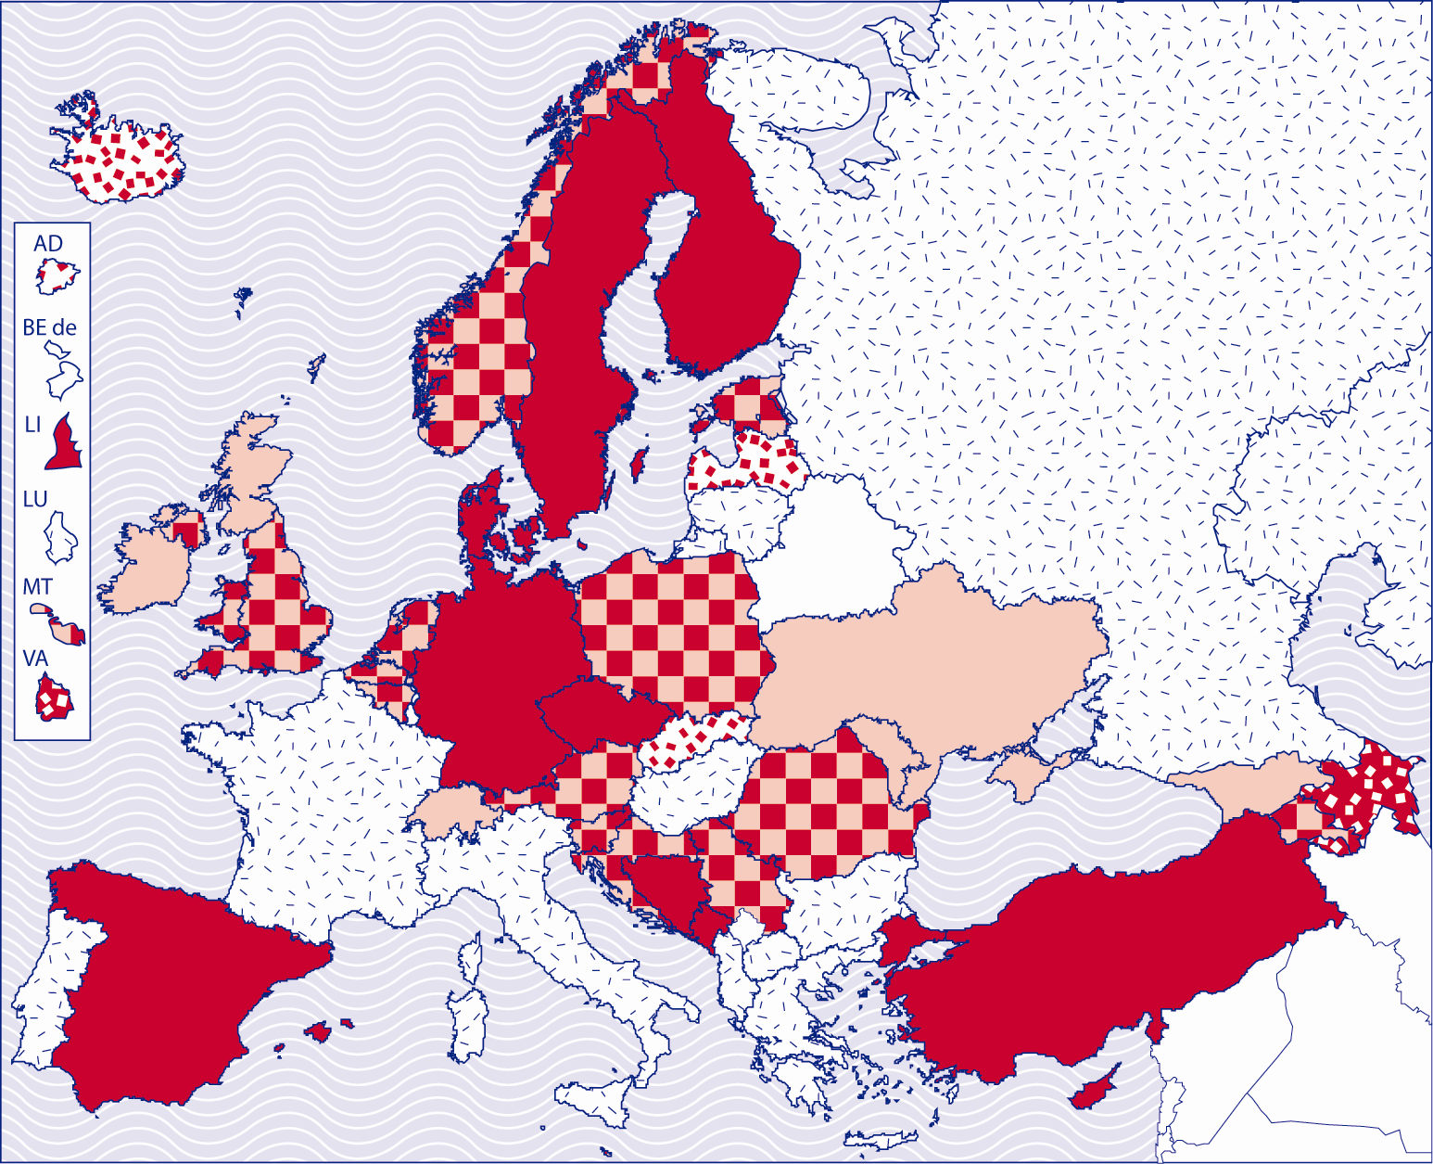

|  |  |
| --- | --- |
|  | countries identifying underrepresented societal groups |
|  | countries with a general policy approach |
|  | countries applying a different approach |
|  | countries not reflecting the goal of widening participation |
|  | Data not available |

**Socio-economic status**

There is no common definition of socio-economic status at European level and countries identifying this group in their national legislation cover a slightly different scope of people, for instance, orphans (MD, GE, RO), students from large families defined as those with four and more children (Georgia, Moldova) and families with socially unprotected status (Georgia).

Some countries use the characteristic of parents' background in order to identify socio-economic status of students. Belgium (Flemish Community) specifically mentions the first generation students (i.e. those that have neither parent with a higher education qualification) as an underrepresented group. In Ireland socio-economic status is based on the occupational background of the students' parents.

In addition, Ireland and the United Kingdom (Scotland) focus on support of pupils from deprived areas. The admission scheme 'Access to the Professions' in Ireland supports talented pupils from deprived backgrounds who due to personal circumstances have better access to study programmes such as medicine, dentistry and law. The scheme encourages considering the context of attainment within selection. Dormant Accounts Funding for Access Initiatives in Institutes of Technology sector in Ireland are designed to enhance access to and participation in the Institute of Technology sector by educationally disadvantaged groups. The United Kingdom (Scotland) identifies proportions of students in higher and further education from each quintile of the population by deprivation. It also looks at proportions of mature students from the most deprived areas combining thus socio-economic background with age as two determinants of underrepresented groups.

The United Kingdom (England, Wales and Northern Ireland) adopted a national programme 'Aimhigher'. It offers a broad menu of activity tailored to local needs of young people from disadvantaged backgrounds including summer school, master classes, visits to universities, subject specific activities and activities for particular groups. Furthermore, a mentoring scheme 'Aimhigher Associates' was adopted too. Associates are higher education students from state schools who provide targeted support and sharing of personal experience, with particular help with applying to university for young people in state schools from poorer backgrounds or no family history of application to higher education.

**Disability**

As with socio-economic status, there is also no European-wide definition of disability and thus national concepts differ. In higher education context some countries try to remove all physical barriers for students and facilitate their access to higher education institutions (Belgium (French Community)) while others apply specific measures by admission to institutions (Cyprus) or during the course of their studies.

The Fund for Students with Disabilities in Ireland provides funding for students with a disability attending recurrently funded and non-recurrently funded institutions that require additional support and services while studying at further or higher education. Funding is provided for students who have serious sensory, physical, learning and/or communicative disabilities.

**Ethnicity**

The concept of ethnicity is not commonly understood across Europe and covers different aspects. But as figures 5 and 10 show, migrant status has strong effect on the likeliness of participating in or attaining higher education. Policy reflects this difference by including ethnicity and/or migration as aspects of underrepresentation in their policy. Mainly immigrant and second generation immigrant status as well as the Roma population are taken into account by Bulgaria, Hungary, Moldova and Romania. But for early school leaving, for example, no separate statistics by migrant background exist for these countries (fig. 5). The relative chances for migrants to attain higher education in those countries, however, are among the most equal in Europe (fig. 10).

Based on the Unified National Admission Exams, minorities living in Georgia receive exam tests available in their languages in Georgia. The Azerbaijanian and Armenian minority entrants with Georgian citizenship have to pass only a general ability test in their native language to be admitted to the higher education institutions and after completion of a one-year Georgian language course, students can follow the studies.

Norway defines migrant status and not ethnicity which is forbidden to monitor due to private data protection. Immigrants are defined as all foreign born with two foreign born parents and the children of two foreign born parents.

While some countries started an action in order to increase a share of ethnic groups being represented in higher education institutions, other countries already noted reversed trend when ethic groups are represented better than the rest of the population given the percentage of an ethic group on entire population.

According to national statistical data, 18 % of all immigrants and 35 % of the second generation immigrants in the age group 19-24 entered higher education in 2007 in Norway. In comparison, the percentage for the entire population is 30. The United Kingdom (England, Wales and Northern Ireland) reports that nearly all major ethnic groups are represented in greater proportions than in the population (see also section 1 of this chapter).

**Age**

Several countries stress age as one of the characteristics of underrepresentation and have adopted policy measures to support entry into higher education from certain age. Which age cohort is already considered mature is very much linked to cultural differences and is also mirrored in the age composition of student population. Ireland and Malta defines mature students as those over the age of 23. In contrast, the age profile of Nordic countries is traditionally higher. In autumn 2010, 61 % of all registered students in Norway were equal or less than 25 years old while 10 % were in the age group of 41 and above.

The United Kingdom (Scotland) provides through its SWAP (Scottish Wider Access Programme) an independent advice to adults who may have missed out on higher or further education first time round and which provides them with access courses which can lead to guaranteed places in colleges or universities.

**Gender**

A few countries mention gender as a feature of underrepresentation. On a general level looking at student population, a clear shift towards female students can be observed as they already outnumber men in tertiary education (see figure 3). However, numbers of men and women in certain study fields differ substantially (see figure 4). Men are overrepresented in MST field whereas underrepresented in education and training, health and welfare and humanities and arts. The differences can also be observed in teaching population in higher education which is still predominantly male (EACEA/Eurydice).

Several countries address particular aspects of gender imbalance. The United Kingdom (Scotland) adopted a scheme showing commitment to the advancement of careers for women in MST. Germany organises workshops, competitions for pupils and so-called girls' days to attract female students in MST.

**Geography**

Particular geographical conditions might influence access to higher education. In this respect, countries strive to ensure access from specific geographical areas, such as high mountainous regions, regions of ecological migration (GE) and rural regions (EE, RO, UA).

Applicants from towns with less than 10,000 inhabitants may benefit from a number of guaranteed budget places in Romania as these areas are recognised as high socio-economic risk environment.

**Military actions**

Last but not least, students or students of parents participating in military conflicts are often recognised as underrepresented groups in Balkan and East European countries.

Children whose parents have participated, died or been lost during military operation are identified as underrepresented group in Moldova and Georgia. In addition, students from conflict regions and descendants of people deported from certain regions during communist regime (GE) and young people who have accomplished military service (MD) are included in the group. Having completed military service, however, is not considered in most other countries, even though it may favourably improve access to higher education programmes.

**Conclusions**

In many areas measures are undertaken, but that they do not allow a coherent picture to emerge. Some countries are very active on many dimensions, while others only focus on few. In many cases characteristics of countries and/or their experiences determine the focus of their social dimension policies in higher education. The definitions used in social dimension policies also reflect this diversity, as for most of them there is too little in common to enable useful comparison within the EHEA.

As social dimension policies in higher education must be responsive to the reality in the individual countries, this is not necessarily a negative finding. The question however, remains as to whether national higher education policy gives sufficient priority to these issues, and to what degree policy is responsive to the results achieved by particular measures.

**Monitoring**

The majority of countries monitor the composition of student body. Although policy approaches of countries differ since some define underrepresented groups while others apply a general approach, many of them have a combination of the two. This is mirrored in their monitoring system. After closer look at ways they monitor the composition of student body, it can be concluded that the tools and criteria do not differ significantly.

**Countries defining underrepresented societal groups** usually collect data related to these groups. However, some countries do not monitor participation and graduation of underrepresented groups (Georgia, Ukraine). A number of countries established databases designed for collecting data on underrepresented societal groups (IE, UK).

Ireland launched the Equal Access Data collection with specific information on underrepresented groups. The data are used to allocate additional access funding per student to higher education institutions. The Higher Education Statistical Agency (HESA) and the Office for Fair Access (OFFA) are in charge of monitoring in terms of recruiting underrepresented groups in the United Kingdom.

Countries with a general policy approach to widening participation have, in many cases, established national institutes which monitor the composition of student body or more specifically, have set up a database for collecting statistical information on higher education (BE(nl), NO). One has to keep in mind that majority of countries combine this approach with defining underrepresented groups and thus the monitoring bodies are identical.

Apart from the regular data collection and design of separate higher education databases, institutes publish reports and surveys assessing higher education environment. For instance, Spanish Observatory assesses whether a ministry secures equal opportunities to all students. In Germany, the National Association for Student Affairs monitors the situation of students via its regular survey, "*The economic and social conditions of student life in the Federal Republic of Germany".*

Although some countries predominantly make use of one specialised institute for monitoring effects of national policies, it is usually interplay of more institutions collecting higher education data. Belgium (French Community), Estonia and Slovenia uses several institutions (National Statistical Offices, Ministries of Higher Education, higher education institutions, Student Unions) to monitor various aspects of higher education studies. Nevertheless, the latter country strives to form a separate system of monitoring of student body.

Countries use different criteria to measure and evaluate the success of specific initiatives. To sum up most of them, they monitor gender (AR, BE(fr), DK, ES, SE), age (BE(fr), DK, ES), national origin (BE(fr), DK), place of birth (AR, NL), level of education of the students' parents (NO, SE), field of studies (AR, BE(fr)) and access path (BE(fr)). Some countries report that they monitor the composition of student body, but do not base their monitoring on certain criteria (LI, SE).

Due to personal data protection, it is not always possible to monitor student body fully in all countries (e.g. Belgium (French Community)). For instance, Finland aims at a share of immigrants among students corresponding to the share of entire population but does not enable to monitor student body according to the ethnic and socio-economic background. Similarly in Norway, ethnicity, disability and religious affiliation is not allowed to be registered.

Finally, countries also monitor the composition of the student body and the impact of national policies in the field of higher education via regular national statistical monitoring (DK, ES).

## 4.4 Transversal measures to encourage participation of all societal groups

The objective to increase the number and diversity of the student population goes hand in hand with the need to create an institutional environment that values the recruitment of non-traditional learners and pays particular attention to student retention in the higher education system. Non-traditional access routes to higher education, services available to students during their studies, provision of flexible higher education programmes and policy initiatives to tackle student under-performance and dropout can therefore be seen as transversal measures making higher education more attractive for social groups that have been under-represented in the past.

This section will first provide an overview of alternative access routes to higher education that can be used by prospective students who do not comply with traditional access requirements. It will then look at services that are commonly available to students, in particular academic and career guidance and services of psychological counselling. Other measures that contribute to widening participation in higher education, namely flexible provision of higher education programmes and the recognition of prior learning for the progression in higher education will be examined in Chapter 6 on lifelong learning. Chapter 5 on outcomes and employability will look at policies targeting the completion of higher education studies and it will examine how different higher education systems address the problem of student under-performance and dropout.

**4.4.1 Non-traditional access routes to higher education**

Non-traditional (or alternative) access routes to higher education are commonly understood as access routes targeting higher education candidates who do not comply with traditional entry requirements. This is either because they followed a short upper secondary vocational path (i.e. a programme, which does not allow access to higher education) or because they abandoned initial education prior to the completion of upper secondary level. This is not uncommon in several countries, as figure 6 shows. In the current policy context, promoting the idea that no talent should be left behind, the theme of non-traditional pathways into higher education gains particular attention. The objective is to extent admissions criteria so that all those who have a capacity to follow higher education studies would be provided with the opportunity to do so, regardless of their prior formal learning achievements.

**Overview of the current situation**

The analysis of alternative access routes to higher education must be carried out in close relation to the current structures of the upper secondary education systems. In fact, one of the most important characteristics of many current upper secondary systems is the absence of a clear boundary between academic and vocational paths. This means that vocational upper secondary programmes often lead to a standard qualification allowing access to higher education studies. Overall, this can be seen as a positive trend that contributes to parity of esteem and equality of different educational choices and pathways.

Eurostat data indicates (see Figure 12) that in Finland, Portugal, Turkey, Cyprus, Sweden, Lithuania, Germany and Estonia, virtually all upper secondary graduates hold a qualification opening access to higher education. The situation is different in countries such as Denmark, Iceland, France, Belgium and the Netherlands, where more than 40% of pupils complete upper secondary education with a qualification, which does not give them direct access to higher education. It is therefore in this second group of countries, where the existence of alternative pathways into higher education might play particularly important role in supporting non-traditional candidates to embark on higher education studies. Yet, even in countries, where virtually all upper secondary programmes lead to a qualification opening access to higher education, alternative entry routes can provide support for learners who left initial education without completing the upper secondary level.

**Figure 12: Percentage of upper secondary graduates finishing a programme with no access to higher education (2008/2009)**

Source: Eurostat



Figure 13 provides an overview of the current situation in the European Higher Education Area with regard to alternative access routes to higher education. It classified the EHEA countries into two groups: The first one includes countries where the traditional upper secondary school leaving certificate (general or vocational) is not the only way to enter into higher education, and where at least one alternative path into higher education exists. The second group comprises countries where the standard upper secondary school leaving qualification remains the only way to embark on higher education studies[5].

The figure shows that out of 29 countries for which data is available[6], 13 countries have already established at least one alternative route to higher education, whereas in 16 countries the access to higher education is still conditioned by the possession of the upper secondary school leaving certificate. Overall, the figure shows that the higher education systems in the countries of Western Europe are characterised by higher flexibility in terms of their entry qualification requirements than other EHEA countries.

Figure 13: Alternative routes to higher education for non-traditional candidates

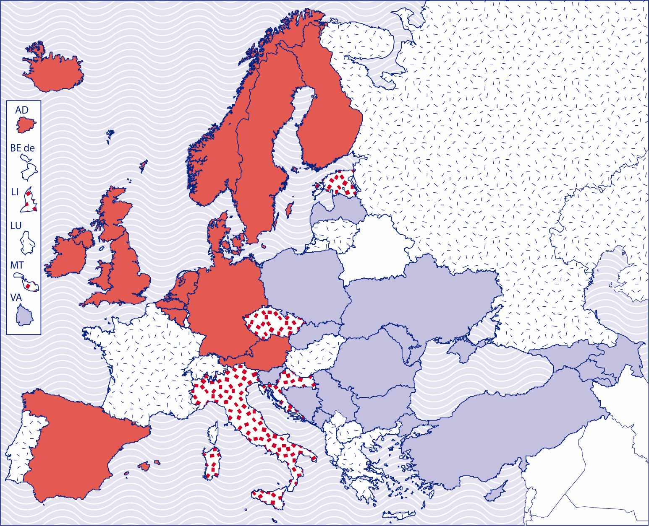

**4 categories:**

|  |  |
| --- | --- |
|  | Alternative routes exist |
|  | No alternative route |
|  | Data difficult to interpret |
|  | Data not available |

Alternative entry to higher education can take different forms and can be based on a range of methods and approaches. Most commonly, alternative entry involves the recognition of the knowledge and skills that prospective non-traditional students acquired outside formal learning contexts (i.e. through various non-formal learning activities, professional experience, volunteering etc.). Besides, candidates who lack the knowledge and skills necessary for higher education study can be provided with the possibility to follow specific preparatory programmes allowing access to higher education. The two sections that follow provide more detailed information on different approaches that can be observed within the EHEA.

**Recognition of the knowledge and skills acquired outside formal learning contexts**

In countries, where alongside standard formal qualifications the admission to higher education can also be granted on the basis of the recognition of non-formal and informal learning, legislation most often expressly refers to such possibility. Yet, legal frameworks regulate this option in different ways and to a different extent.

In some countries, legislation refers to alternative access to higher education in a relatively open way, i.e. it does not refer to any specific categories of non-traditional learners or to any approaches to be used in alternative admission procedures. In Finland, for instance, both Universities and Polytechnics Acts state that those who lack formal qualifications may be eligible for higher education studies if higher education institution judges that they have sufficient knowledge and skills to follow the programme they applied for. Similarly in Sweden, the Higher Education Ordinance specifies that students may be accepted to the first cycle studies based on their professional experience or other circumstances, as long as they have the potential to benefit from the studies.

Regulatory frameworks are sometimes more prescriptive and provide further details relating to various aspects, including the categories of learners who are eligible or methods and approaches that should be used when evaluating the knowledge and skills of non-traditional applicants. In Spain, for instance, legislation refers to different age categories of non-traditional candidates and specifies procedures that apply to each category. It states that those older than 25 may be admitted on successful completion of a special university entry examination aiming to evaluate their general knowledge as well as their abilities for the studies chosen. Applicants older than 40 do not need to take an entry examination if they possess professional experience linked to the courses they want to take. Legal frameworks can also include other conditions. For example in Germany, alternative access to higher education is only open to those who hold specific vocational qualifications (e.g. master craftsmen, technicians, professional managers etc.) and have at least three years’ experience in their professional field.

The United Kingdom represents a specific case, as there is no legislation referring to alternative entry into higher education, but higher education institutions commonly accept non-traditional candidates who do not comply with standard entry requirements. This is related to the fact that universities are autonomous institutions responsible for the quality of their qualifications and the recruitment of their student population. They can therefore set their own admission criteria and conditions. Nevertheless, at the national level, a support has been provided to boost the implementation of alternative entry routes into higher education: the Quality Assurance Agency for Higher Education (QAA) has published a code of practice, which specified a range of evidence that may be considered in judging the potential of a prospective non-traditional student. According to the document, the evidence might include all prior learning of candidates, including that achieved in the workplace.

**Preparatory programmes for non-traditional higher education candidates**

Alongside the recognition of prior non-formal and informal learning, some countries have put in place specific preparatory programmes targeting non-traditional higher education candidates who need additional support in gaining the skills required for higher education study before they enter higher education. These programmes are primarily directed at learners who followed a short upper secondary programme not opening access to higher education or who left upper secondary education before completing it. They most often lead to a qualification that is recognised as an alternative to the upper secondary school leaving certificate.

Provision of preparatory courses for non-traditional higher education candidates is relatively common in Ireland and all areas of the United Kingdom. In Scotland, for instance, such preparatory courses (also known as “access courses”) can be provided in the framework of the Scottish Wider Access Programme, which aims to support adult learners to embark on higher education studies. In England, Wales and Northern Ireland, access courses are provided by further education colleges and designed with the support of higher education institutions. They combine subject specific content with elements related to key competences necessary for study in higher education. A typical access course takes a year of full-time study but many are also available on a part-time basis.

In virtually all countries, there are also possibilities for mature studentns who do not hold a necessary higher education entry qualification to follow programmes leading to the standard upper secondary school leaving certificate. These “second chance” programmes are often delivered under various flexible arrangements such as evening, part-time or distance courses. Despite the fact that this type of provision cannot be regarded as an alternative access route to higher education, it plays an important role in providing non-traditional learners with an opportunity to achieve a standard qualification allowing access to higher education studies.

**Statistics and monitoring**

Apart from different approaches to alternative access to higher education, it is also important to examine the extent to which these alternative options are used in practice. However, countries reporting the existence of at least one alternative entry route to higher education are often unable to provide information on the proportion of students entering into the system on the basis of alternative admission procedures. It indicates that in the majority of countries this area is not subject to a regular general/nation-wide monitoring.

Where quantitative data is available, alternative pathways into higher education do generally count only for up to 5% of all entries. Only England reports significantly higher proportion of those who enter higher education through a non-traditional entry route (around 28% of all entries).

The information provided by national authorities can be compared with recent Eurostudent research (Eurostudent, 2011), which allows to quantify the role of traditional and non-traditional entry routes in different higher education systems (see Figure 13). The data covers 22 countries and is based on students’ responses to a question on the access route they have taken to enter higher education.

Figure 14: Students entering higher education through a regular route (upper secondary qualification) in %, 2009/10



Source: Eurostudent

The figure shows that in Turkey, Slovakia, Italy, Poland, Croatia, Romania, Latvia and the Netherlands all students entering higher education are in the possession of the traditional upper secondary school leaving certificate. This confirms the information provided in Figure 1, which indicates that most of these countries do not provide any systematic possibilities to enter higher education without the standard upper secondary school leaving qualification. Only the Netherlands reports that non-traditional higher education candidates aged over 21 can be admitted to higher education on the basis of the recognition of prior learning. However, according to Eurostudent data, this possibility is rarely used in practice.

At the other end of the spectrum lie Finland, Ireland, the United Kingdom (England and Wales) and Sweden, where between 70% and 80% of higher education students enter the system through traditional access routes, whereas the rest of the student population takes an alternative entry pathway. The contextual information provided in the text above confirms that all these countries have already established at least one alternative access route to higher education, namely the access based on the recognition of the knowledge and skills acquired outside formal learning contexts (Finland, Ireland, the United Kingdom and Sweden) or preparatory courses for non-traditional higher education candidates (Ireland and the United Kingdom).

The majority of the 11 countries situated in the middle of the spectrum, namely France, Germany, Denmark, Austria, Norway, Malta, Spain and Portugal, report that they have a systematic policy approach to alternative entry routes for non-traditional learners (see Figure 1). In these countries, alternative access routes represent between 2% and 15% of all admissions, which indicates that this option has been implemented to variable degrees. This could be related to different amounts of support that central authorities provide to higher education institutions in the implementation of alternative admission procedures.

Eurostudent research also provides information on characteristics of those entering higher education through non-traditional access routes.

Figure 15: Students entering higher education through alternative routes by education background and transition route in % (2009/10)



Source: Eurostudent

Data reveals that students belonging to the category of delayed transition students[7] and students characterised by a low education/social background[8] are those who often take non-traditional access routes. In Finland, Ireland and Sweden more than one in three students characterised by a low education/social background or delayed transition have taken an alternative access route to enter higher education. This confirms that the theme of alternative access to higher education ought to be seen as a key component of debates relating to the social dimension in higher education.

**Prospective developments**

With regard to future developments in the field of alternative entry into higher education, some countries see the establishment of their national qualification frameworks based on learning outcomes as a mean to enhance the development of alternative access routes to higher education. It is expected that the shift to clearly identified learning outcomes will support alternative entry pathways in two different ways: First, clearly identified knowledge, skills and competences needed for study at higher education level could allow the implementation of measures to recognise non-formal and informal learning as a part of standard admission procedures. Second, national qualification frameworks are also expected to clarify content of different national qualifications, which could allow certain “non-traditional” certificates and qualifications to be better understood and potentially accepted by higher education institutions as an alternative to a standard upper secondary school leaving certificate. In Ireland, for instance, since the establishment of the National Framework of Qualifications (NFQ), there has been an increase of those entering higher education with further education awards, i.e. non-traditional higher education entry qualifications. In 2007, these students represented approximately 10% of entrants (Eurydice, 2011). The impact of the implementation of national qualification frameworks on alternative entry routes to higher education is therefore a theme to be followed within further analyses.

**4.4.2 Student services**

Student services provided within the higher education sector are commonly regarded as an integral part of the social dimension, as elements contributing to the quality of the student experience and to widening access to higher education. They can support prospective students before entry to higher education, contribute to students’ performance and success during their studies, and accompany higher education graduates in their transition to the labour market. They are also crucial to achieve the goal to make higher education more inclusive, as the ministers acknowledged in their 2007 communiqué.

**Overview of the provision**

While higher education institutions can offer multiple student services, the 2011 BFUG reporting exercise paid particular attention to the three types of services, namely academic guidance services, career guidance services and services of psychological counselling. It intended to provide an overview of the extent to which these services are ensured by higher education institutions.

Available data indicates that both academic and career guidance are commonly available to students in the majority of countries. Only Andorra, Croatia, Montenegro and Ukraine indicate that these services are not included in the standard provision of higher education institutions. The provision of psychological counselling services seems to be slightly less common: only around two thirds of countries report that higher education institutions commonly provide these services to students. Yet, this could be related to the fact that psychological counselling is often ensured by external providers, rather than by higher education institutions themselves (for more details, see the information on the organisational aspects provided further in the text).

Apart from the above-mentioned services, around half of the countries provide information on other services that are commonly available to higher education students. They mainly include healthcare and accommodation services, as well as services related to sport, social and cultural activities of students.

Several countries (Bosnia and Herzegovina, the Czech Republic, Denmark, Croatia, Iceland and Slovenia) provide specific student services for those with special needs, in particular students with disabilities. The aim of these services is to ensure that these students are provided with academic and career guidance adapted to their needs, and that they can follow their studies on the same footing as other students.

A few countries refer to the provision of academic and career guidance services targeting prospective higher education students, in particular upper secondary pupils. These services mainly take the form of various outreach activities/programmes aiming to enhance the motivation of learners to enter higher education and allow prospective students to make appropriate choices for their study career. For example in the United Kingdom, the Scottish Lothians Equal Access Programme for Schools (LEAPS), supports talented young people in 59 state secondary schools and provides them with information and encouragement to apply to higher education. The programme targets young people with little or no family experience of higher education or those who may have experienced adverse social and/or economic circumstances. Montenegro also reports various systematic activities in attracting and guiding prospective higher education students, namely an information portal available on the Internet and regular higher education fairs organised by the Ministry of Education in cooperation with other actors active in the field of career guidance.

**Organisational patterns**

From the organisational perspective, student services provided by higher education institutions appear as a complex field. While a certain number of services are often ensured at the central level of higher education institutions, others may be provided by individual faculties or departments. For example in Slovenia, central enrolment offices ensure academic and career guidance as well as services related to accommodation, student mobility and the recognition of ECTS obtained in other higher education institutions. Alongside, individual faculties provide additional and more targeted academic and career guidance support to students. Similarly in the Czech Republic, student services are provided by special advisory units as well as by distinct departments, dean’s offices, study offices etc.

Individual higher education institutions do not necessarily ensure the provision of all services available to their students. This applies in particular to health services or services of psychological counselling, which are often provided by external institutions. In Serbia,for instance, academic and career guidance are most often provided inside higher education institutions (in career guidance centres), whereas services of psychological counselling are for the most part ensured by external providers, in particular medical centres and polyclinics.

Some countries have established independent legal entities responsible for the provision of various student services. This is the case in Norway, where student services fall under the responsibility of the Student Welfare Organisation and its 24 local branches. This organisation ensures services in the areas such as student accommodation, catering and health, as well as services related to sport, social and cultural activities of students. A similar situation can be observed in Germany, where the public institution “Studentenwerk”, with branches all over the country, offers comparable services. Denmark has established a self-governing institution Student Counselling, which ensures the provision of psychological counselling.

**Student services and legislative frameworks**

Legislative frameworks address the provision of student services in different ways. While in some countries it is legally binding for higher education institutions to offer certain types of student services, in other instances such obligations do not exist. For example in the Czech Republic, according to the Higher Education Act, public higher education institutions are obliged to provide applicants, students and other persons with information and advisory services relating to higher education studies as well as to labour market opportunities for graduates. In Denmark, universities are legally obliged to offer special guidance for students who are at risk of dropping out. In Norway, according to the Act on Student Welfare Organisations, all Norwegian higher education institutions are obliged to collaborate with the Student Welfare Organisation. The United Kingdom represents a different model: higher education institutions are not obliged to offer the provision of student services, given their institutional autonomy. However, the lack of explicit directives does not necessarily mean the absence of student services. Scotland for example reports that all Scottish higher education institutions offer academic and career guidance services as well as psychological counselling services, and many also provide comprehensive health services to students.

**Funding of student services**

Budgets of higher education institutions largely appear as the main source of funding of various student services. Yet, several countries also refer to other financial sources.

In countries such as the Czech Republic, Estonia, Finland and Slovenia,the European Social Fund seems to play an important role in the development of services available to higher education students. This is done either through projects focusing specifically on the provision of student services, or through initiatives having a wider scope, where student services represent only one area of action. The second case can be illustrated by the Slovenian project “Primus”, which aims to support the quality development of higher education and increase the competitiveness of graduates. The project consists of six major action lines, one of them supporting 19 higher education institutions with the provision of student services.

Complementary funding can also come from various national-level funds. This is the case in Denmark, where student services are partly financed from the Globalisation Fund, created as part of the Government’s Globalisation Strategy, which includes initiatives in the area of research, education, innovation and entrepreneurship. Besides, some universities have also received a special grant (in total DKK 10 million in 2009-2010) to test different career guidance initiatives.

In countries, where independent entities providing student services exist, these organisations are financed in various ways. For example in Norway, the Student Welfare Organisations are partly financed by compulsory students’ contributions and partly by the government. In Denmark, the Student Counselling service is financed by the state.

**Conclusions**

##### Overall, student services appear as a complex field characterised by a heterogeneity of arrangements, both at national and cross-national levels. It is therefore quite challenging to provide a comprehensive picture of this area in a comparative international perspective. The information collected in the framework of the 2011 BFUG reporting exercise indicates that in most EHEA countries, higher education institutions ensure provision of a relatively wide range of student services. Yet, it is difficult to evaluate the extent to which these services are accessible to all students nor the degree of relevance with regard to different student needs. 5 Fees and Support

Issues of student fees and support are difficult to understand and compare accurately and clearly at European level. This is because national realities are complex and there are many dimensions to be considered. For example, the statement, "students pay fees in country x" may seem clear, but it lacks sufficient information to understand the system. Does the term "students" refer to all or some students? If some, what are the criteria that determine which students pay fees? How much do students pay, (the range of fees)? Are the fees paid upon enrollment or after graduation?

Even if answers are provided to all of these questions, the information remains partial. The rest of the picture needs to be filled in with information on the student support system. Are students or their families able to access public financial support in the form of grants, loans or tax relief? If so, under what conditions and criteria?

This section therefore aims to show only some main patterns and approaches in national higher education systems, relating the most important elements of national fee systems with student support. It can, however, only be an overview of such a complex topic, and more detailed information is needed from national sources.

**5.1 Student Costs**

FIGURE 16 Prevalence of fees In the first cycle

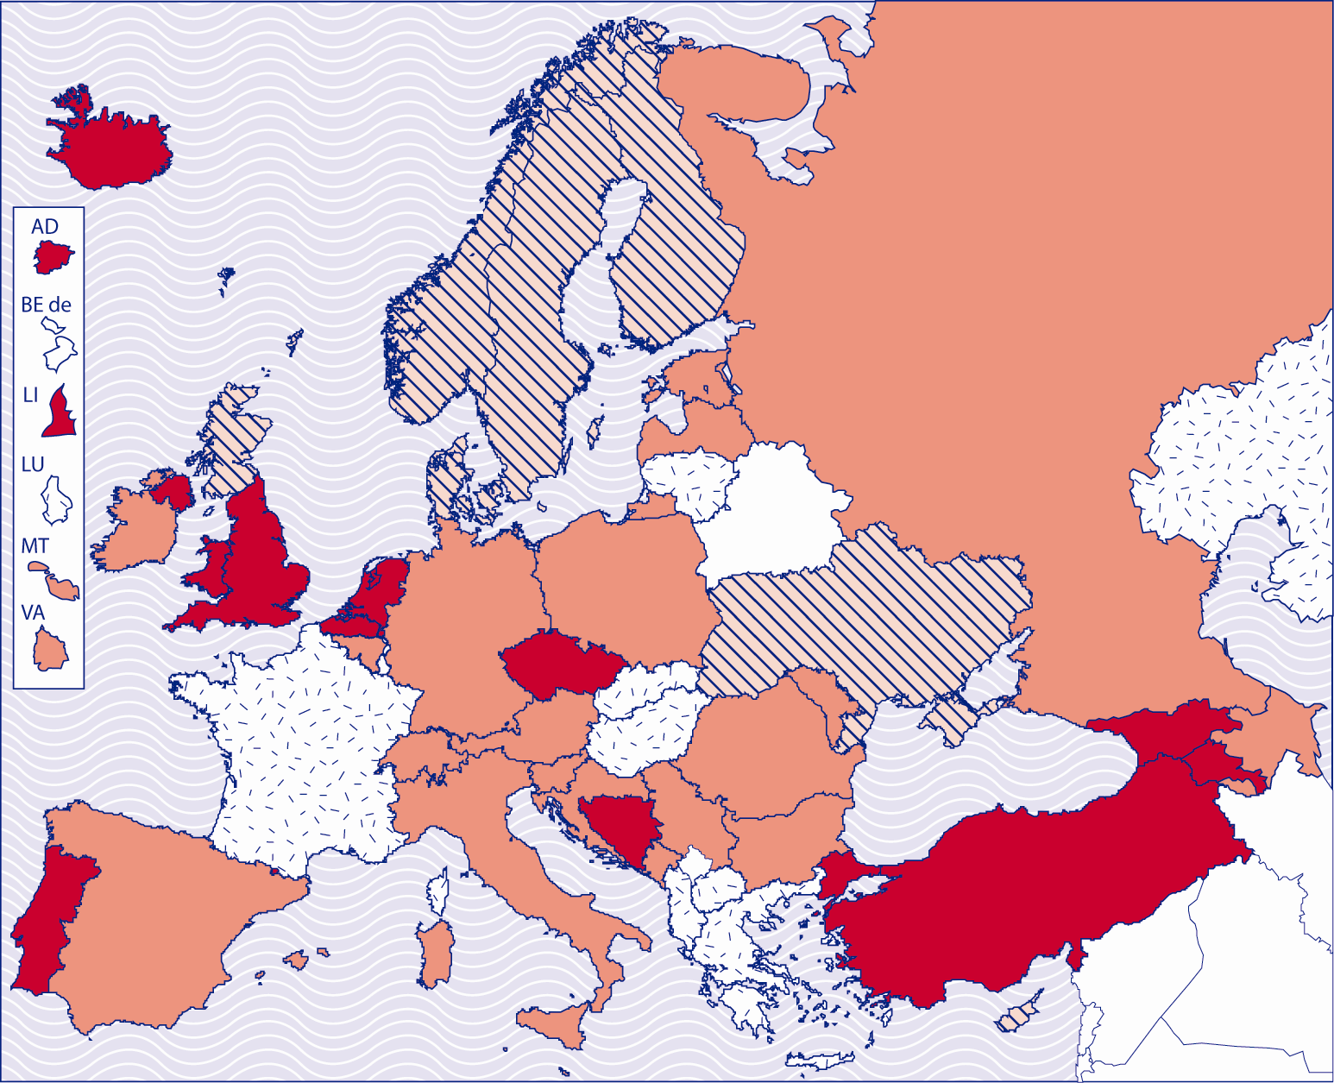

|  |  |  |  |  |  |  |  |
| --- | --- | --- | --- | --- | --- | --- | --- |
|  | All students pay fees |  | Some students pay fees |  | No students pay fees |  | Data not available |

Figure16 provides an overview of the prevalence of fees in the first cycle. While the information does not take account of the amounts of fees charged, it does differentiate between countries where all students are charged fees and those where only some students are charged fees. Overall it is evident that across the European Higher Education Area fees are very commonly charged. Indeed only in 7 countries is the first cycle organised without recourse to fees. There is a clear cultural and geographical aspect to such no fee models, as these can be found to be predominantly a characteristic of Nordic systems.

For approximately half of the countries of the EHEA, fees are charged to some students. This implies that there is recourse to criteria for distinguishing fee-payers and non fee-payers in these countries, and this aspect will be examined... below.

Meanwhile in 12 national systems all students are required to pay fees.

Figure 17 SHARE OF BACHELOR STUDENTS WHO PAY FEES

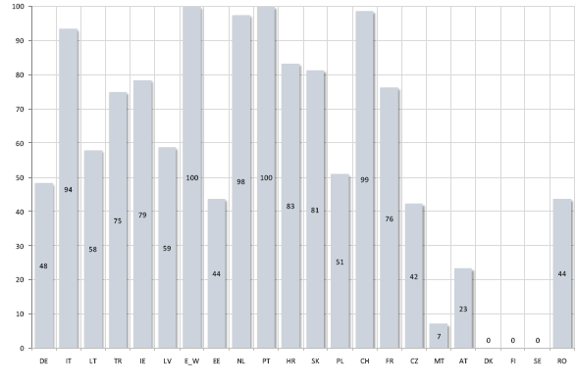

Eurostudent information echoes these findings. Indeed Figure x illustrates the great diversity between systems, and provides a more precise picture of the percentages of students paying fees in participating Eurostudent countries. All or practically all students can be found to pay fees in Italy, Netherlands, Portugal, Switzerland and the UK (England and Wales) while none pay fees in the Nordic countries. A further 6 countries have above 70% of fee-payers, while a further 7 have more than 40% of fee-payers. Apart from the fee-free Nordic countries, only Malta (7%) and Austria (23%) have low overall percentages of fee-payers.

Figure 18: Share of household funding in total expenditure of higher education institutions

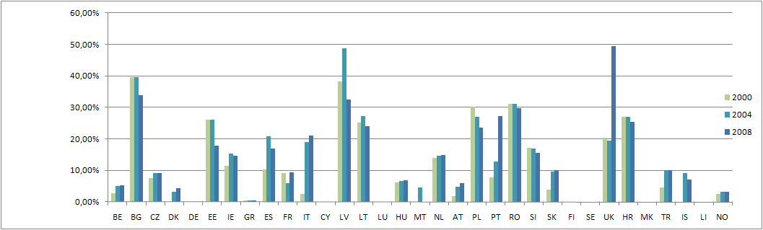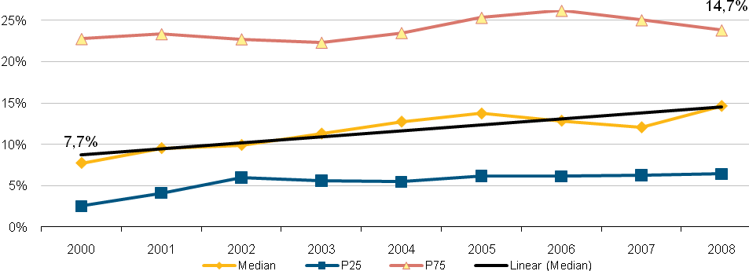

Differences in approaches to fees are also reflected in Eurostat information on the share of household funding in total expenditure of higher education institutions (Fig x) Across the countries for which data is available, there has been a steady overall increase in this percentage between 2000 and 2008 with the median value reaching nearly 15%. However, the country differences are striking. There is a significant group of countries (13) where the share of household expenditure remains less than 10% in 2008. A further 6 countries lie between 10 – 20% with the same number lying between 20 – 30%. The countries with the most significant share of household expenditure are the United Kingdom (49%), Bulgaria (33%) and Latvia (32%).

**WHO PAYS FEES?**

While it is clear that there are major system differences in terms of the prevalence of fees, it is also true that there are considerable differences in the criteria used to determine which students pay fees, and how much they pay.

Financial considerations (economic condition of students) are used as criteria for charging fees in Belgium (French-speaking and Flemish communities), France, Italy and Cyprus. Meanwhile in Spain financial considerations are taken into account with regard to the amount of fees charged – but not the decision on whether or not fees are charged.

A number of countries (Estonia, Spain, France, Cyprus, Latvia, Lithuania, Hungary, Slovenia and Turkey) use academic performance criteria as a means of distinguishing who pays fees and/or the level of fees paid.

However, the majority of countries use a combination of criteria. Latvia, Lithuania, Hungary and Slovenia combine criteria based on academic performance with those based on the type of study programme. Belgium, both French-speaking and Flemish communities, combines financial criteria related to the economic conditions of students with criteria linked to the field of study. Meanwhile, France combines financial criteria with academic performance. Cyprus and Spain combine financial criteria both with academic performance and the type of study programme. In the case of Spain, however, the decision of whether or not a student pays fees is determined only by financial criteria related to the family. Other criteria are then used in relation to the amount of fees paid.

In the Czech Republic, Poland and Slovakia higher education institutions are free to set their own fees for programmes taught in a foreign language. However in all other cases, fees are limited to admission charges and to charges to students who extend the expected length of studies beyond more than an academic year. In Latvia, although fees are charged to a majority of students, fees per credit for programmes taught in a foreign language are generally higher than those for programmes taught in the national language.

Figure 19: Monthly fees as a share of total monthly expenditure for bachelor students not living with parents

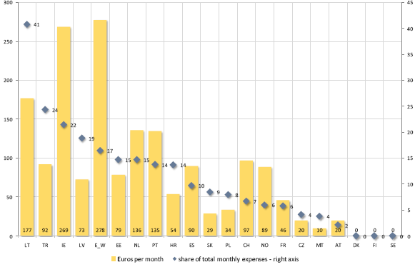

The impact of fees upon individual students depends on a number of factors. The level of fees is a significant issue, although fee levels affect students differently according to their particular economic situation. Moreover public authorities are also able to alleviate the impact of fees through the design of the support systems.

In the majority of Eurostudent countries that are charging fees for Bachelor students, the average fee is below €100 per month. High absolute amounts of fees are charged in England/Wales, Ireland, and Lithuania, where the monthly values range from over €170 to almost €280. In Denmark, Finland, and Sweden, Bachelor students study free of charge.

The relative meaning of fees expressed as share of students’ total monthly expenditure varies greatly between the countries. Bachelor students have to dedicate less than 10% of total expenditure on fees in half of the countries.

In one group of countries – Ireland, Turkey, and Lithuania – the share of fees roughly ranges between 1/5 and 2/5 of the students’ total monthly expenses. Along with accommodation costs, this, therefore, determines a large chunk of the students’ budget.

Besides the 3 Scandinavian countries which waive fees completely, in 3 other countries – the Czech Republic, Malta, and Austria – the relative impact of fees is rather low (below 5% of monthly expenditure).

These country clusters do not, however, remain intact, when one further element of the design of fee schemes is taken into consideration. That is the question of how many students actually have to pay fees. In Italy, Turkey, Ireland, England/Wales, the Netherlands, Portugal, Croatia, the Slovak Republic, Switzerland, and France, at least 75% or more of the Bachelor students are subject to paying fees. In Italy, England/Wales, the Netherlands, Portugal, and Switzerland, it is practically 100%.

## 4.5.2 Student Income and Public Support

Figure 20: Main forms of student support

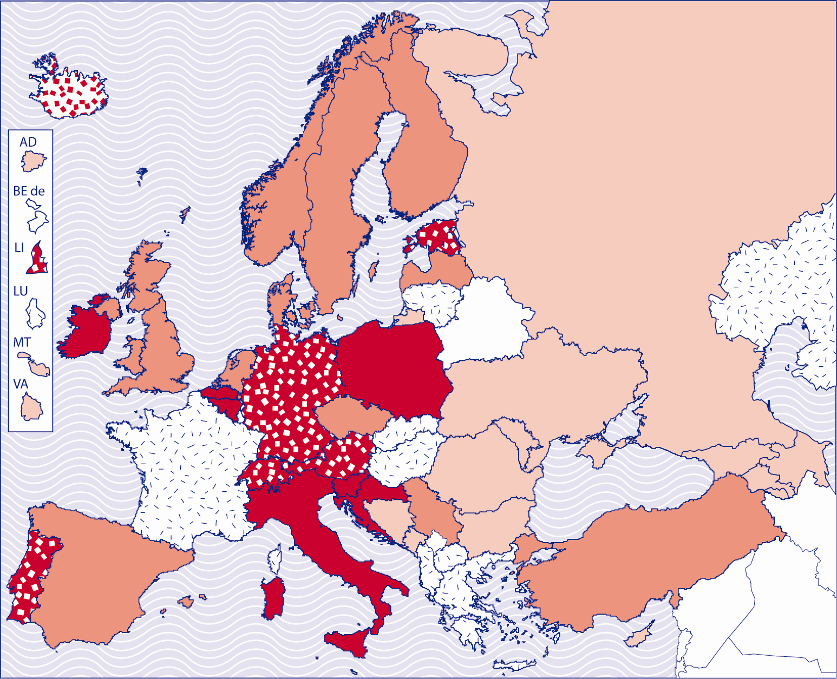

|  |  |
| --- | --- |
|  | Grants + loans + tax benefits |
|  | Grants only |
|  | Grants + loans |
|  | Grants + tax benefits |
|  | Loans only |
|  | Data not available |

Fees should not be considered in isolation of information about student support and student income. Indeed it is only when information on fees and support is combined that an accurate picture of the national system can be ascertained from a student perspective.

Figure x shows the main forms of student support used across the EHEA. Here it is interesting to see that the main patterns of support indicate some significant geographical and cultural differences. 13 systems have grants as the main source of student support, and it is interesting that the great majority of these systems are located in central and eastern Europe. Loans are an important feature of support, but only in the case of Iceland are they the primary, exclusive form. More commonly they are found to operate in conjunction with grants, as is the case in 15 systems.

Support is not only channelled to students in the form of grants and loans, however. Tax benefits for parents also play a significant role in many countries. Indeed in 7 countries tax benefits for parents are combined with grants for students as the main form of support, while in a further 6 countries loans are also part of the combination.

Figure 21 PERCENTAGE OF FEE-PAYERS AMONG RECIPIENTS OF PUBLIC SUPPORT

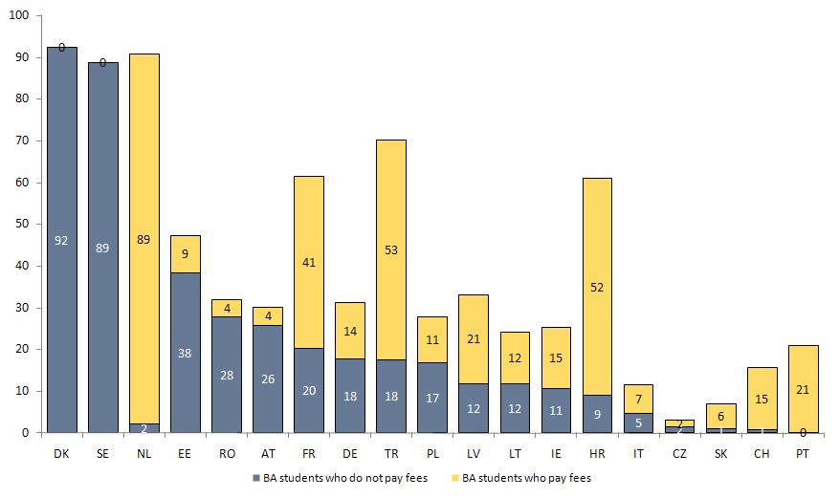

Figure 22 PERCENTAGE OF FEE-PAYERS AMONG NON RECIPIENTS OF PUBLIC SUPPORT

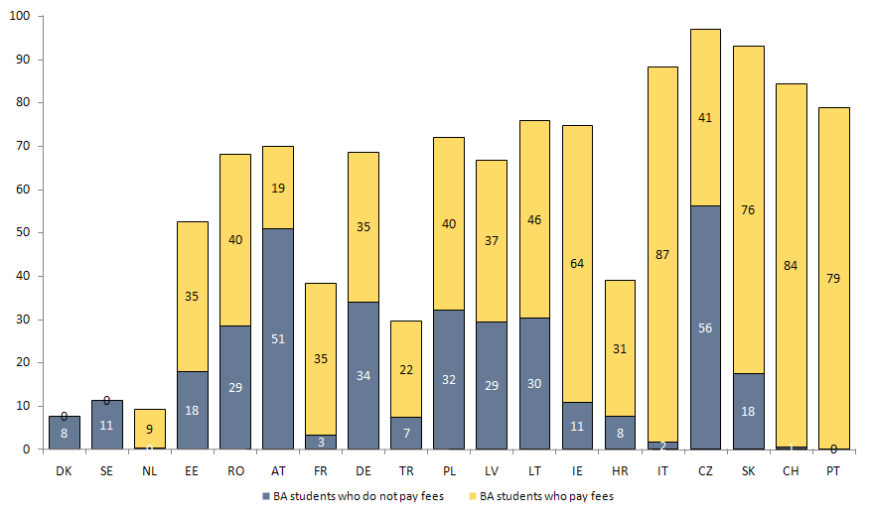

Eurostudent information enables a picture to emerge of how those in receipt of student support may or may not be affected by fees. Some noteworthy issues can be seen. Firstly it is striking that in a number of countries the likelihood of paying fees is not greatly affected by receiving public funding. This is the case in the Netherlands, France Croatia, Germany, Latvia, Poland and Portugal, as well as in the Nordic countries that are not concerned by fees. However, in Estonia, Romania and Austria the fact of receiving public support greatly reduces the likelihood of paying fees. These findings should also be seen in relation to information from the BFUG questionnaire that shows that in many countries the most significant criteria for distinguishing which students pay fees are the mode of study, type of study programme or field of study chosen rather than to social characteristics of the student population.

**Figure 23 Aid to students as a percentage of public expenditure on education**

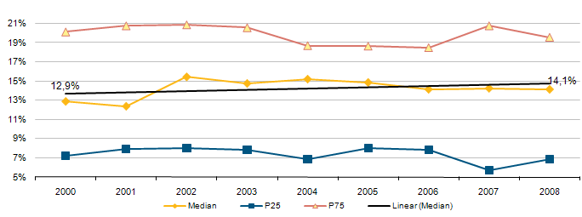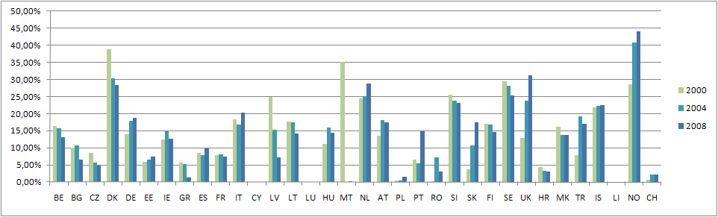

The quality and strength of the student support system is directly related to the amount of money made available through the public budget. Figure x presents the evolution of the student support budget between 2000 and 2008 showing the amount of money countries provide as public financial aid to students as a percentage of the overall higher eduation budget.

While the median level of investment in student support has increased slightly - from 12.9 % to 14.1 % – there are very divergent underlying patterns and realities within European countries. Overall, three relatively balanced groups of countries can be identified. There are those where a significant increase in the share of money allocated to the student financial system has taken place. This is the reality for Germany, Hungary, Portugal, Slovakia, the United Kingdom, Norway and Turkey.

The second group of countries is where the share of investment in financial aid has changed little between 2000 and 2008. This is the case for Estonia, Ireland, Spain, France, Italy, Poland, Finland and Iceland. There are also countries where a downward trend can be observed, such as Belgium, Bulgaria, Czech Republic, Denmark, Greece, Latvia, Lithuania, Romania, Slovenia and Sweden.

Irrespective of these three national trends, however, very significant differences can be percieved in the percentage of the higher education budget devoted to student support. The percentage ranges from as high as 44% for Norway to as low as 1.5% for Poland. The countries that invest most – above 15% - as a percentage of the higher education budget on the student support system are Norway, the United Kingdom, Denmark and the Netherlands. The countries that invest least – less than 5 % - as a percentage of the higher education budget are Poland, Romania, the Czech Republic, Croatia and Switzerland. While these figures also need to be considered in relation to the size of the overall higher education budget, it is clear that they signify major differences in student support across Europe.

Another aspect to be noted is the countries where changes have been significant. The United Kingdom stands out as the country with the most significant increase, moving from 12.9% in 2000 to more than 30 % by 2008. Norway, already starting at a high percentage of investment in 2000 (29%) also moved upwards by 15% to reach 44%. Denmark appears as a mirror image of Norway, starting at 39% in 2000 and ending at 28% in 2007. However, the most dramatic fall in financing is in Latvia – from 24.9% in 2000 to 5.1% in 2007. As Latvia was later to suffer the most severe higher education budget cuts as a consequence of the financial and economic crisis (see Chapter 2) this fall in student aid funding earlier in the decade is therefore highly significant. The Czech Republic, although cutting "only" 4.4% during the first 8 years of the decade did so from a low starting point of 8.6% in 2000. Thus in reality this fall is also highly significant, and likely to have made a major impact.

The information presented in this chapter therefore needs to be considered in relation to these levels of funding, and in relation to the question of how effectively efforts are made to target funding.

**WHO RECEIVES FINANCIAL SUPPORT?**

The philosophical question that underlies the choices made by countries is the nature of a fair system of student financial support. Clearly there are a number of aspects to be considered. Firstly, should available resources be spread as widely as possible, but with the general consequence of reducing the impact of such support? Or should a minority group or groups – however the criteria for membership are constituted - receive a more significant share of the resources? If it is decided that resources should be targeted to increase their impact, which students should qualify for support? In terms of the social dimension is it fairer and more effective to target support on the basis of financial need? Or to what extent should those who perform well in their studies be rewarded by financial support? Does such funding reinforce social inequity by rewarding students who are already socially advantaged at the expense of those who may have equal potential, but are unable to develop it through social and financial disadvantage? Whether as the result of implicit or explicit debate, national systems of student support all take position in relation to these questions.

**Criteria for Awarding Grants**

Denmark, Finland and Sweden have a system of universal grants for full-time students provided that certain basic requirements of study performance are met. Therefore in these countries no criteria are required. For all other countries the main question is whether grants are provided on the basis of financial need or academic performance, or a combination of these two main criteria.

The largest share of countries combine the two criteria, providing some grants on the basis of financial need and others on the basis of academic performance. Estonia combines criteria based on the course or field of study with merit.

A small group of countries, consisting of Belgium (French community), Ireland, Netherlands, Finland, the United Kingdom, Liechtenstein and Norway, provide grants on the basis of financial need only, although it may be a requirement that students progress in order to continue receiving grants.

**Criteria for awarding loans**

It is noticeable that whereas universal grants are available only in Denmark and Sweden, loans are available to all students in 12 national systems (Belgium (German Community), Denmark, Germany, France, Lithuania, Hungary, Netherlands, Slovakia, Finland, Sweden, and Norway), although in Hungary students over 40 are not eligible. In the case of France, very few students actually take out a student loan.

One significant difference between grants and loans is reflected in the finding that need-based criteria are relevant in nearly all national systems for grant allocation, but only considered in 2 national loan systems (Belgium (French-speaking Community) and Poland). Thus when finance is offered in the form of loans, and is to be paid back by students, it is generally more widely available to the student population.

Meanwhile in Bulgaria, Estonia, Spain, the UK and Iceland eligibility for loans depends on criteria related to the particular type of study programme. In Spain, loans are limited to new second cycle master programmes, while in the UK the student loan system is designed for students in the first cycle. In some countries (eg Estonia and Slovakia), only full time students are able to benefit from student loans.

**Tax benefits and other support**

Tax benefits and other financial allocations to parents of students can also play a significant role in a number of European countries. Such information does not, however, concern those students who are themselves parents.

Belgium, Czech Republic, France, Germany, Greece, Austria, Poland, Slovenia and Slovakia provide both tax benefits for parents, and other financial allocations to parents. In a further 7 countries Estonia, Ireland, Italy, Latvia, Lithuania, the Netherlands and Liechtenstein parents of students in higher education also receive tax benefits, but are not able to claim additional financial allocations. Thus in all these countries support to families rather than to individual students is a significant aspect of the system.

This contrasts with the picture in the remaining systems where there are neither tax benefits nor other financial entitlements for parents. In the Nordic countries (Denmark, Finland, Iceland, Norway and Sweden) this reality is clearly central to the cultural understanding of higher education as a provision for independent adult students.

However, the Nordic countries are by no means the only countries where there is no tax or financial benefits for parents. This is also the reality in two of the larger members of the EU (Spain and all parts of the UK) in a number of central and eastern European countries (Bulgaria, Hungary, Romania) as well as in Cyprus, Malta and Turkey.

**Student Perceptions of Sufficiency of Funding**

**Figure 24: Students’ assessment of sufficiency of funding to cover monthly costs by finance-related characteristics – students not living with parents**

*Students with a dependency on a specific income source with (strong) agreement in %*

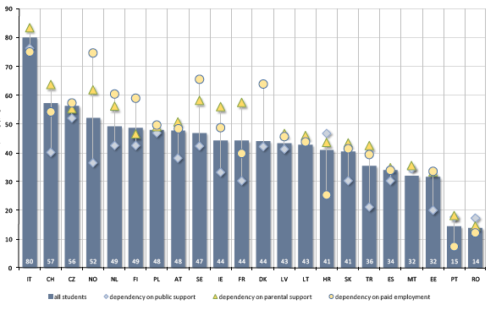

While countries may have their own system to provide different degrees of financial support to different students, students are in the best position to judge the sufficiency of the funding support that they receive. In this respect Eurostudent is able to highlight differences in perception.

Figure 24 shows the assessment of students who are not living with parents with a dependency upon a certain income source. Dependency means that the respective income source amounts to more than 50% of the students’ total income. The focus of the analysis is on the 3 main components for funding of students: parental support, students’ earnings from gainful employment and public support.

The average satisfaction figures for the different components already tell a story: Whilst on average 48% of students depending on parental support assess their financial situation as (very) satisfying, 47% of students dependent on paid employment and 37% of students with a dependency on state support do so. The same picture is drawn if the focus is set on the share of (very) dissatisfied students.

Concentrating on the highest shares of satisfaction by source, 3 country cluster become apparent: There are 9 countries where a majority of students who are depending on parental support are (very) satisfied with their financial situation: Italy, Switzerland, the Czech Republic, Norway, the Netherlands, Austria, Sweden, Ireland, and France.

Dependency on paid employment is considered by a majority of students as (very) satisfying in countries with older students, but not exclusively so; this refers to Italy, Switzerland, the Czech Republic, Norway, the Netherlands, Finland, Sweden, and Denmark.

When public support is the dominant source of income for students, only in Italy and the Czech Republic more than 50% of the depending students (strongly) agree that this income source provides sufficient means.

1. Migrants here are those who were born abroad.
2. BiH, CZ, DE, DK, ES, FI, LI, MN, SE, TR
3. GE, IE, MD, UA, UK(sc)
4. AR, BE(fr), BE(nl), CY, EE, HR, MT, NL, NO, PL, SI, RO, RS, UK
5. The second group includes a few countries (e.g. CZ?, SI, TR), where under exceptional circumstances, particularly talented higher education candidates who do not hold the upper secondary school leaving certificate can be granted access to higher education. However, as this concerns only exceptional cases and often only certain fields of study (e.g. arts programmes in CZ?, SI), these countries cannot be regarded as having a systematic provision of alternative entry routes into higher education. Alongside, the second group also includes countries where candidates without necessary qualifications can be admitted into higher education, but cannot be awarded a higher education degree if they do not complete their upper secondary studies (e.g. CZ?, UA).
6. Excluding countries for which data is difficult to interpret
7. Delayed transition: “characteristic used to define a type of student, who entered the higher education sector for the first time at a later stage in his/her life. This new focus group has been developed in order to capture a group of students on which a lot of policy focus is being laid. All students, whose delay between receiving HE entrance qualification at school and entering HE for the first time amounts to more than 2 years are considered delayed transition students. All students, whose delay was less than 2 years, but whose entry qualification was obtained outside the normal school system are also considered delayed transition students, …”(Eurostudent 2011, p. 220)
8. Low education/social background: “Low education/social background: socio-economic background of a student due to his/her parents’ social standing. The parents’ social standing is approximated by their highest educational qualification according to ISCED-97-code. The highest educational attainment of either the father or the mother is taken into account. The ISCED levels 0, 1 and 2 are considered as low qualification background…” (Eurostudent 2011, p. 219)