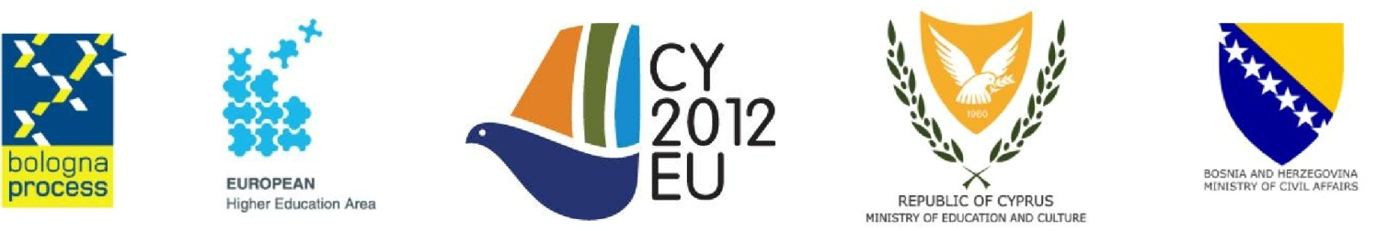

Doc. Code: BFUG_CY_BA_33_6.1_Annex1
Last modified: 24_08_12

Terms of reference
on
Reporting on the Implementation of the Bologna Process

Name of the working group
Reporting on the Implementation of the Bologna Process
Contact persons (proposed Co-Chairs)

Andrejs Rauhvargers - Latvia (andrejs.rauhvargers@lu.lv)
Germain Dondelinger - Luxembourg (germain.dondelinger@mesr.etat.lu)
Composition
Austria, Belgium/Flemish Community, Finland, Germany, Arūnas Mark (Lithuania)
Norway, Turkey, ENQA, ESU and EUROSTAT

Purpose and/or outcome
To further refine the methodology of monitoring and measuring progress:
- to provide reliable, comparable data and to take stock of progress towards realising the European Higher Education Area and the strategy “Mobility for better learning”;
- to make further progress in the construction of a structured and standardised monitoring system consisting of indicators and qualitative analysis;
- to allow for comparisons to be made between countries and to allow for monitoring changes over time within countries as well as between countries;
To prepare an overall report on the implementation of the Bologna Process for 2015, integrating data collected by EUROSTAT, EUROSTUDENT and Eurydice.
References to the Bucharest Communiqué

Improvement of data collection ... to underpin political goals
We welcome the improved quality of data and information on higher education. We ask for more targeted data collection and referencing against common indicators, particularly on employability, the social dimension, lifelong learning, internationalisation, portability of grants/loans, and student and staff mobility.
We ask EUROSTAT, Eurydice and EUROSTUDENT to monitor progress in the implementation of the Bologna Process reforms and the strategy “Mobility for better learning”
Specific tasks
- to analyse the experience in data collection and processing in the 2009-2012 period with a view to optimize and further improve the methodology;
- to identify the key issues to be covered by the report and the way in which they should be addressed (quantifiable indicators or qualitative analysis) according to the call of ministers to “more targeted data collection and referencing against common indicators, particularly on:
  - employability,
  - the social dimension,
  - lifelong learning,
  - internationalisation,
  - portability of grants/loans, and
  - student and staff mobility.”
- to specify the indicators to measure progress in the 2012-2015 period and data required;
- to define the survey questionnaire which should
  - be based on a refined 2009-2012 questionnaire where possible to ensure continuity;
  - allow collection of information from the Bologna countries including the areas ministers underlined above.
- to assist Eurydice in drafting the overall report for approval by the BFUG in advance of the 2015 Ministerial Conference.
Reporting
Minutes of working group meetings will be made available by the Bologna Secretariat.

BFUG should also receive regular reports and updates.
To allow for good communication with BFUG as a whole and for the necessary consultations, progress reports should be submitted at least a week before each BFUG meeting. In between BFUG meetings, updates can be circulated by the Bologna Secretariat via e-mail.
The final report will be presented and discussed at the BFUG meeting in January 2015.
Meeting schedule
[dates and locations are just tentative, will be decided at a later stage]
First meeting: Riga, 15 November 2012
Second meeting: Luxembourg, 21 January 2013
Third meeting: Riga, 13 June 2013
Fourth meeting: Luxembourg, 10 November 2013
[Probably no need for meeting in January 2014 – Data collection will have just started]
Fifth meeting: Riga, July 2,2014
Sixth meeting: Luxembourg Nov 14,2014
Seventh meeting (beginning of 2015, to be announced if necessary)

Additional remarks

